
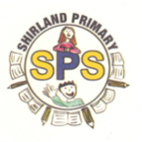
Zebras 2024 Autumn 1 and 2
History - What was the Stone Age?
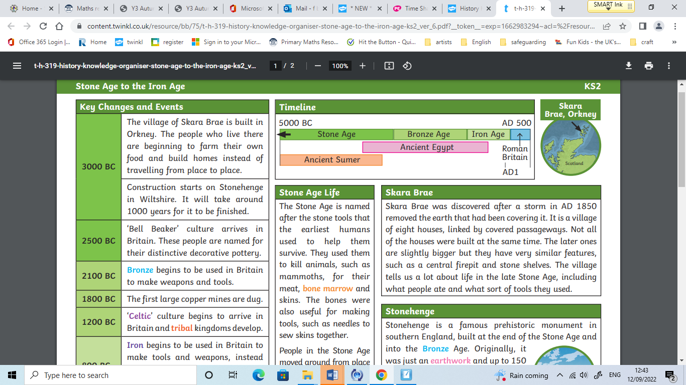 | Skara Brae – Skara Brae is an important village on the island of Orkney, Scotland, that has taught us a lot about how people lived during the Stone age. It was discovered in 1850 after a bad storm removed some of the earth that covered it. The village has eight houses and covered passageways between them. The objects discovered there have shown us what people ate, what their homes looked like and what tools they used.  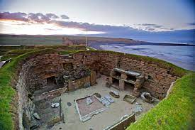  Stonehenge – Stonehenge is a famous prehistoric monument that is in Southern England. It was built from the end of the Stone Age into the Bronze Age. In the beginning it was an earthwork, with up to 150 people buried there. The huge stones you see there today were added at different stages.  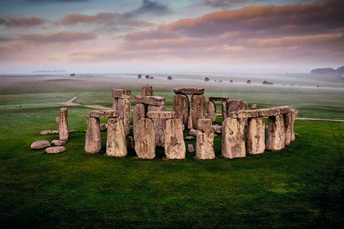  Hillforts - People in the Bronze Age and Iron Age lived in roundhouses. These could be very large and would have housed many people. One household might have had two houses, one for living and one for cooking and making things. In the Iron Age, these houses were sometimes rectangular and were often gathered in farming communities on hills. These were known as ‘hillforts’.  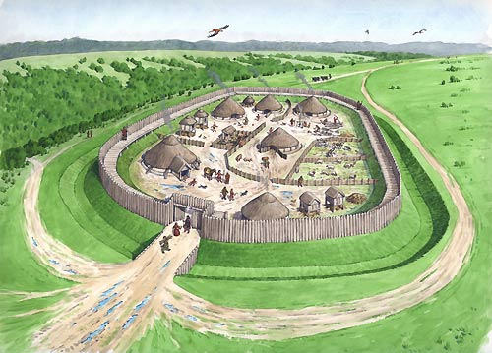
Key Vocabulary
Word | Diagram | Definition
BC | 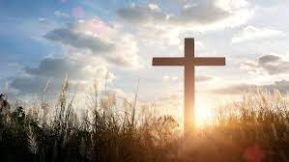 | The period of time ‘Before Christ’
hunter gathers | 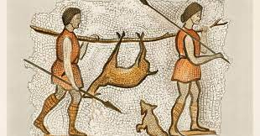 | People who live by hunting and fishing, and harvesting wild food
nomadic | 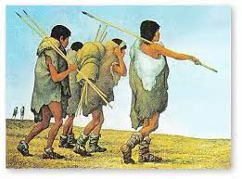 | Someone who travels from place to place and doesn’t live in one place
prehistoric | 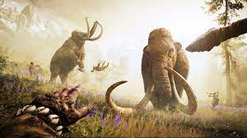 | The time before history was written down
Palaeolithic | 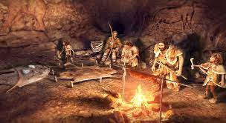 | The first part of the stone age, lasting 2.5 million years
Mesolithic | 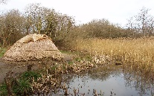 | The middle part of the stone age.
Neolithic | 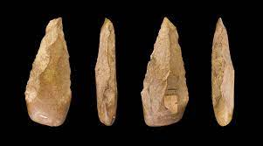 | the later part of the Stone Age, when polished stone weapons and tools were made

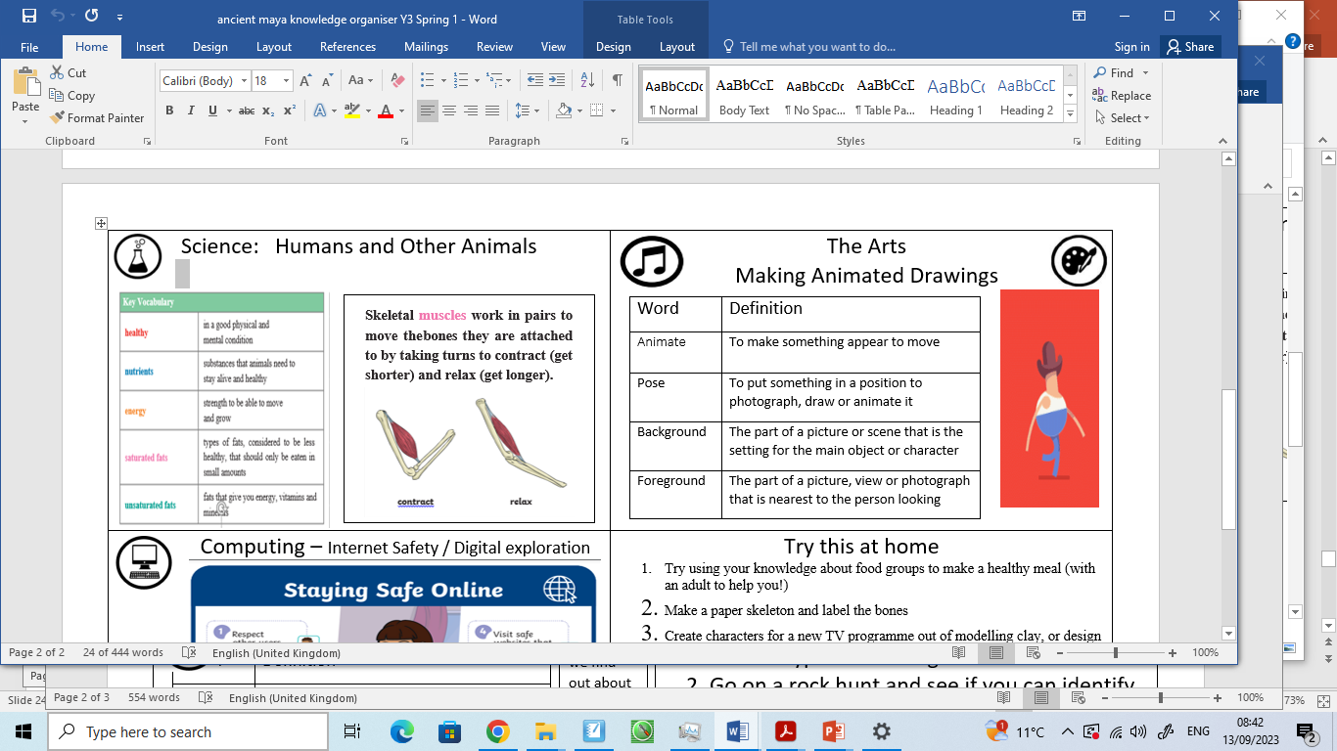  Vocabulary |     The Arts – Gestural Drawing with Charcoal
  nutrition | Food and how it works in your body
  carbohydrate | The body’s main source of energy
  protein | A food group that helps your body grow and repair
  vitamins | Help us to be healthy and improve our immunity
  minerals | Help us to form strong bones and teeth
  Word | Definition | 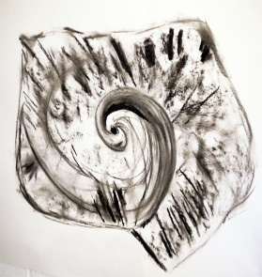
  Charcoal | A black, brown or grey drawing material made from the burning of wood or peat,
  Gestural drawing | A free form of sketching that attempts to simply draw an object or movement.
  Tone | How light or dark something is | 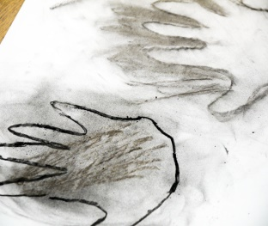
  Positive & Negative Shapes | Positive shapes are the shapes of actual objects. Negative shapes are the areas between these objects.
  Silhouette | A shadow drawing of an object, in a solid colour, with no details
  Computing – basic skills | Try this at home  - Make a typical Stone Age home  - Use your art skills to sketch rocks  - Complete a food diary for a week – how healthy are your meals?  - Collect food labels and work out which are healthy foods  - Make a skeleton and label it!
  Word | Definition
  Font | The style and size of the letters
  Document | A piece of work, similar to having a piece of paper or a book on your desk
  Graphics | Digital pictures
  Edit | Changing and improving your work

